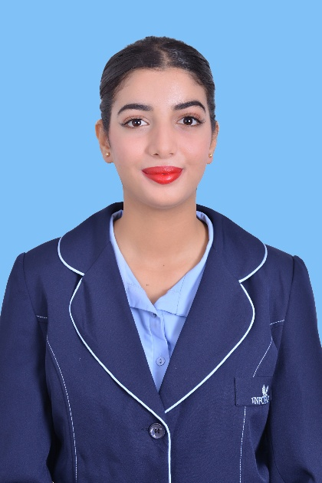
SAHAR ELBOUMTIRI
F&B and Lounge Operations
Qatar Airways Candidate
Rabat, Morocco | +212 7 78 91 59 27 | saharelboumtiri@gmail.com

PROFESSIONAL SUMMARY
Dedicated and highly presented Hospitality Professional with a specialized INFOHAS Aviation & Hospitality Diploma and 5-star luxury hotel experience. Proven track record of delivering "5-star" Food and Beverage service at the Four Seasons Hotel and managing high-volume passenger interactions at Casablanca International Airport. Expert in creating "Moments of Magic" for premium customers through meticulous attention to detail, proactive service, and trilingual fluency in English, Arabic, and French.

CORE COMPETENCIES & SKILLS
- Luxury F&B Service: Fine Dining Etiquette, Mise en Place, Beverage Service, and Food Safety Standards.
- Lounge Operations: Premium Hub Lounge procedures, Passenger Journey Management, and Hostess duties.
- Service Philosophy: Passion for "Surprise and Delight" service, solution-oriented mindset, and customer-centric approach.
- Professionalism: Exceptional grooming standards, cross-cultural communication, and adaptability in fast-paced environments.

PROFESSIONAL EXPERIENCE
Waitress Intern (5-Star Luxury) Four Seasons Hotel | Rabat, Morocco Jul 2025 – Oct 2025
- Delivered world-class Food and Beverage service in a high-end 5-star environment, strictly adhering to luxury brand standards.
- Executed flawless mise en place and service sequences to ensure a seamless dining experience for premium guests.
- Anticipated guest needs to create "Moments of Magic," consistently receiving positive feedback for personalized service.
- Collaborated with a diverse team of professionals to maintain the highest quality of F&B presentation and cleanliness.
Customer Service Agent International Airport of Casablanca | Morocco Dec 2023 – May 2024
- Managed premium passenger queries in a friendly, timely, and efficient manner within a high-pressure aviation hub.
- Upheld strict brand and grooming standards while facilitating smooth check-in and boarding procedures.
- Resolved customer concerns with a solution-oriented approach, ensuring a positive brand image for the airport and airline partners.
Sales Attendant Parfois | Rabat, Morocco Dec 2021 – May 2022
- Enhanced customer experience through proactive assistance and detailed product knowledge.
- Maintained high standards of visual merchandising and personal presentation to align with brand expectations.

EDUCATION
INFOHAS Hospitality and Aviation Accredited Diploma Rabat, Morocco | Jul 2024 – Jan 2026
Specialized Modules: Food & Beverage Services, 5-Star Hospitality, CRM, Aviation & Cabin Crew Training, and English for Aviation.
High School Degree Morocco | 2023 – 2024

LANGUAGES
- English: Fluent (Written and Spoken)
- Arabic: Fluent (Native)
- French: Fluent (Written and Spoken)

